UNIVERSITI TUNKU ABDUL RAHMAN

FACULTY OF INFORMATION COMMUNICATION TECHNOLOGY (FICT)

ACADEMIC YEAR: 2024

OCTOBER 2024 TRIMESTER

**Cascade Amplifier Design**

**AV = -144.5**

Course Details:

Year and Trimester: 2024 / October 2024

Lecture Group: L1,

Tuesday 11:00am -1:00pm,    
Wednesday 1:00pm – 3:00pm,    
Thursday 12:00pm – 2:00pm

Lecture’s Name: Muhammad Syaiful Amri bin Suhaimi

Lecture’s Email: syaifulamri@utar.edu.my

Student’s Details:

|  |  |  |  |
| --- | --- | --- | --- |
| Student’s Name | Student ID No. | Course | Year/Sem |
| Shu Mee Ang | 2303988 | CT | Y2 S1 |

**Objective**

To design and analyse a BJT amplifier using either a **Voltage Divider Bias** or **CE Emitter Bias** configuration, ensuring it meets the specified **unloaded gain** and operates successfully under loaded conditions.

**Introduction**

Amplifiers are fundamental in electronic systems for signal processing and amplification. A properly designed amplifier ensures stability, minimal distortion, and consistent gain. This assignment involves designing a BJT amplifier and analysing its performance both theoretically and through simulation using Multisim. Ensure the design can satisfy the provided gain and component requirements while maintaining reliability under unloaded and loaded conditions.

**Theory & Design Calculations**

**1. Assumptions**

* Voltage of BE equal to 0.7V (base-emitter voltage using Silicon transistor).
* The β of transistor more than 100.
* ​ Vt = 26mA (Thermal Voltage).
* The Source resistance, Rs = 50 ohm.
* The Load resistance, Rl = 4.7k ohm.
* The Vcc is 30v and the Vs is 100mV(peak) and 1k Hz with 0 degree.
* Current of Emitter and Current of Collector have possibly same value.​ (assuming negligible base current).

**2. Key Equations**

1. **Voltage Gain (Unloaded):**

1. **Voltage Gain (Loaded):**

1. **Bias Resistor Calculations:**

1. **Current and Voltage Calculations:**

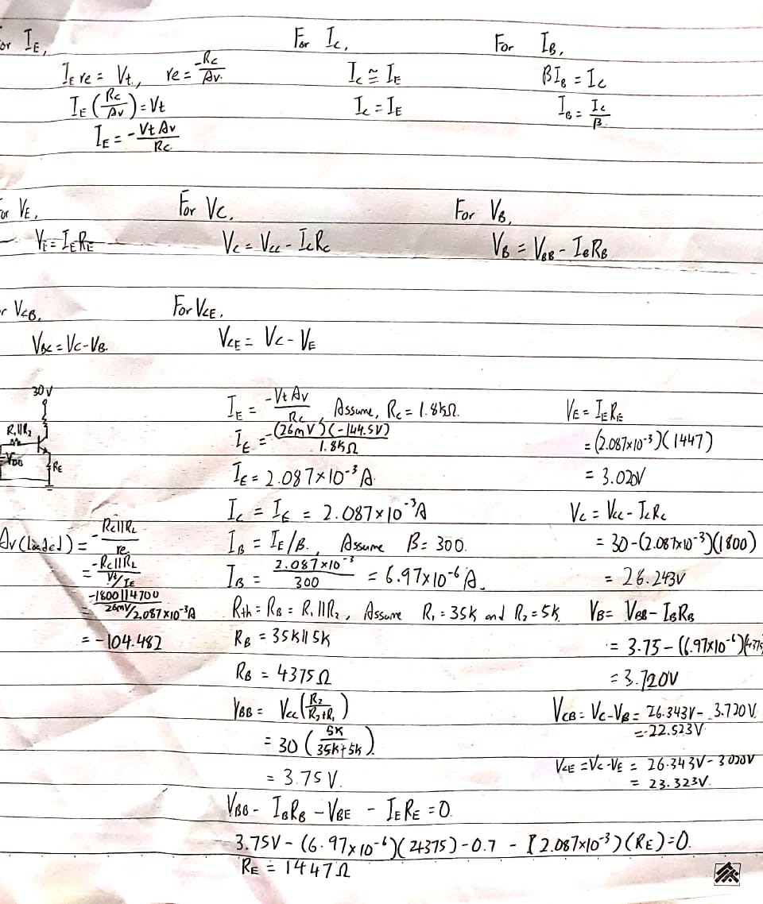

1. **Theory Calculations**



**Simulation**

* 1. **Multisim Circuit Design**

Simulate the circuit for unloaded and loaded conditions:

* + Unloaded: open the RL.

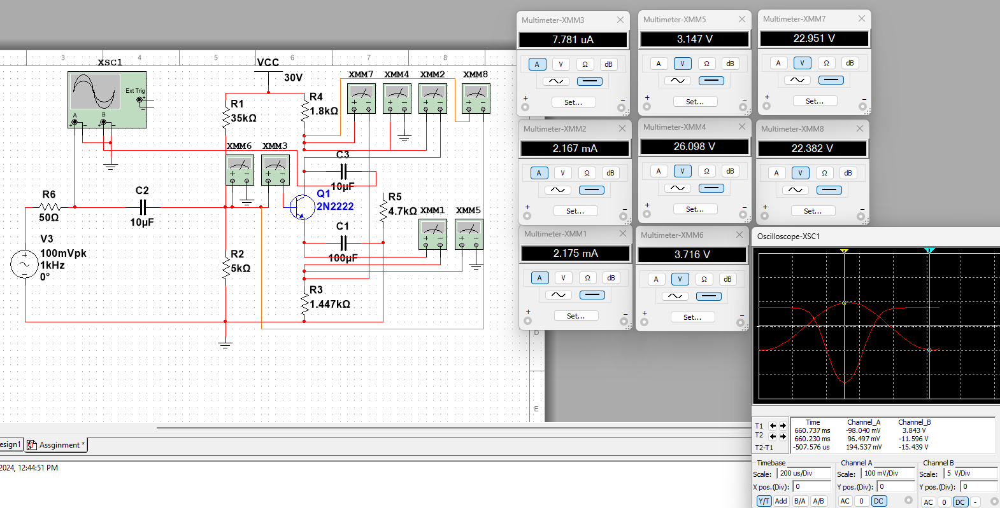

* + Loaded: Include RL.

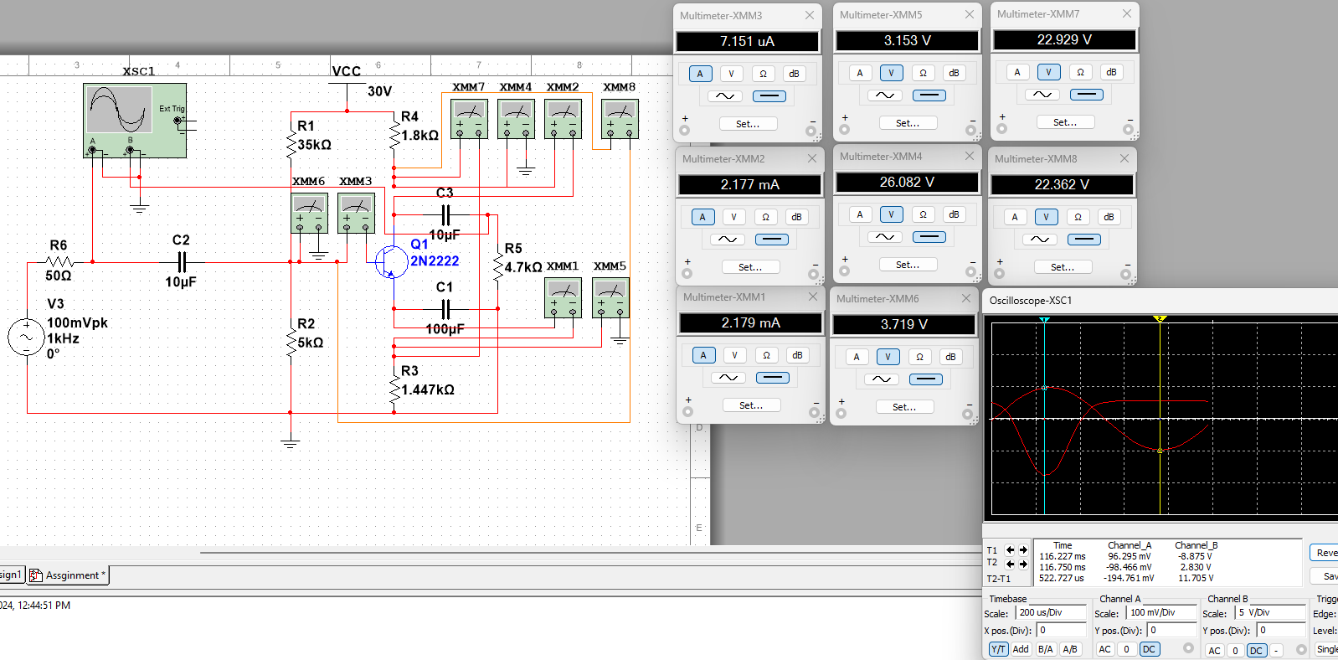

**2. Results**

| **Parameter** | **Theoretical Value** | **Simulation Value** | **Unit** |
| --- | --- | --- | --- |
| Av (Unloaded) | −144.5 | -79.363 | V/V |
| Av ​ (Loaded) | -104.482 | -60.168 | V/V |
| R1 | 35000 | 35000 | Ohm |
| R2​ | 5000 | 5000 | Ohm |
| RC​ | 1800 | 1800 | Ohm |
| RE​ | 1447 | 1447 | Ohm |
| IBQ | 6.87*10^-6 | 7.15*10^-6 | A |
| IEQ | 2.087*10^-3 | 2.171*10^-3 | A |
| ICQ | 2.087*10^-3 | 2.178*10^-3 | A |
| VEQ | 3.020 | 3.152 | V |
| VCQ | 26.243 | 26.091 | V |
| VCEQ | 23.323 | 22.929 | V |
| VCBQ | 22.523 | 22.362 | V |

**Summary & Conclusion**

In this amplifier design, most calculated and simulated values are closely aligned, confirming that our design and theoretical approach are solid. However, we noticed the discrepancies in the unloaded voltage gain, loaded voltage gain, and base current. These differences can be explained by a few factors:

Ideal Assumptions: Theoretical calculations often assume ideal conditions, such as perfect transistor behaviour and exact component values. In practice, real components deviate slightly, leading to differences in results.

Temperature Effects: Transistor behaviour is affected by temperature changes, which aren't considered in theoretical calculations that assume a constant temperature. In reality, temperature will influence performance effectively.

Frequency Response: Capacitors in the circuit can affect gain at the operating frequency. Calculations often ignore these frequency-dependent effects but become significant in practice.

Therefore, the amplifier can still meet stability requirements but with discrepancies of unloaded voltage gain, loaded voltage gain, and base current.These discrepancies highlight the need to account for real-world factors like temperature, component tolerances, and frequency response in amplifier design to improve accuracy and ensure reliable performance.

Reference

**Boylestad, R. L., & Nashelsky, L.**  
Electronic Devices and Circuit Theory (12th Edition). Pearson Education.

**Sedra, A. S., & Smith, K. C.**  
Microelectronic Circuits (7th Edition). Oxford University Press.

**Razavi, B.**  
Fundamentals of Microelectronics. Wiley.